**GIT**

* **Git is a version control system**
* **Git helps you keep track of code changes**
* **Git is used to collaborate on code**

**GIT HUB**

**GIT HUB is a web based Git repository hosting services**

**ACCOUNT CREATION**

**(**[**https://github.com/**](https://github.com/)**)**

**VISUAL STUDIO CODE**

**WINDOWS**

**GITHUB REPOSITORY: "We are creating a folder using Git."**

* **REPO NAME :**

**and CREATE REPOSITORY**

**There are two option : creating a new file or uploading a existing file**

**"Coding can be done in a code editor, but it cannot be done in GitHub."**

**"We copy the GitHub folder to Visual Studio and work with it in Git."**

**GIT DOWNLOAD**

**"Once you've downloaded Git, open the command prompt in your system."**

**Set of : USERNAME:**

**EMAIL ID :**

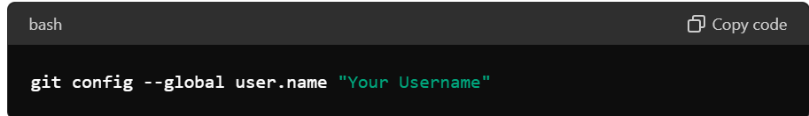

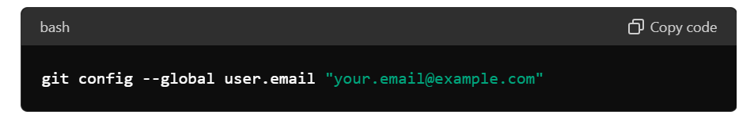

**AND OPEN VISUAL STUDIO CODE**

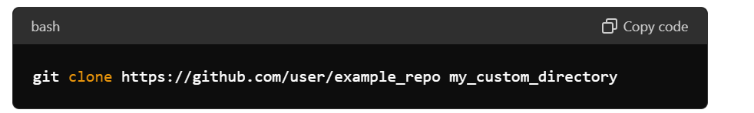

**This link name is : origin**

**cd change folder**

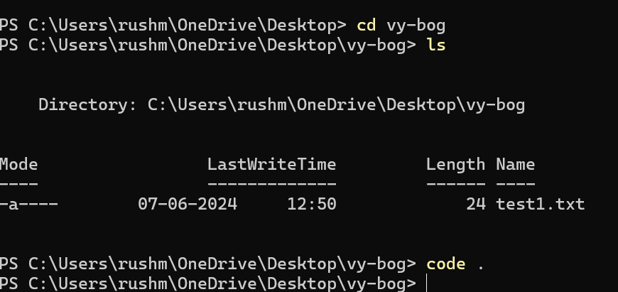

**"And when I create a new file locally, I need to bring that file to GitHub."**

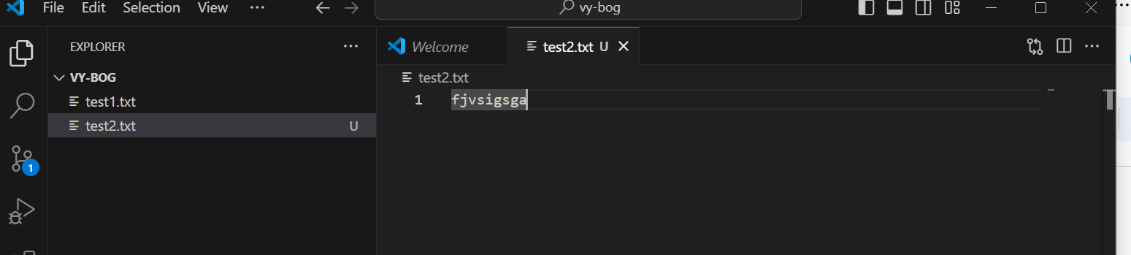

**git status**

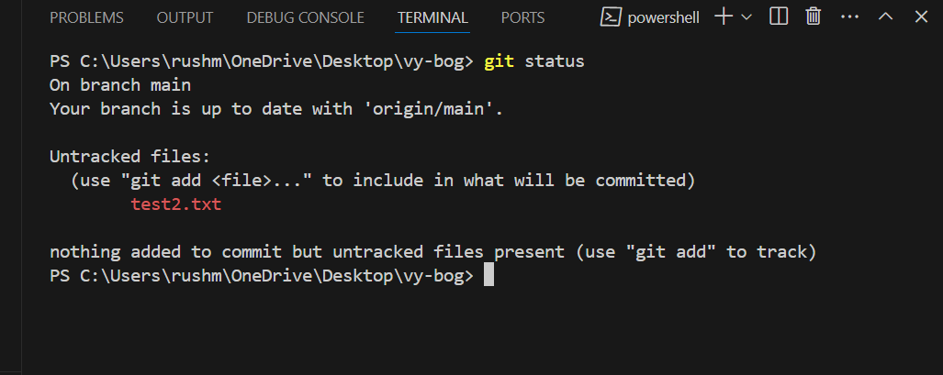

**Untracted to tracked**

**Staging area**

**"The file that's in the staging area needs to be committed to the local Git."**

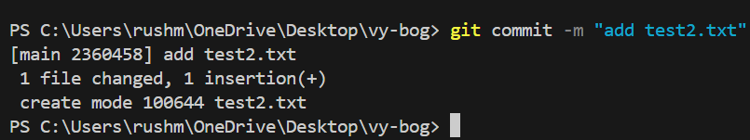

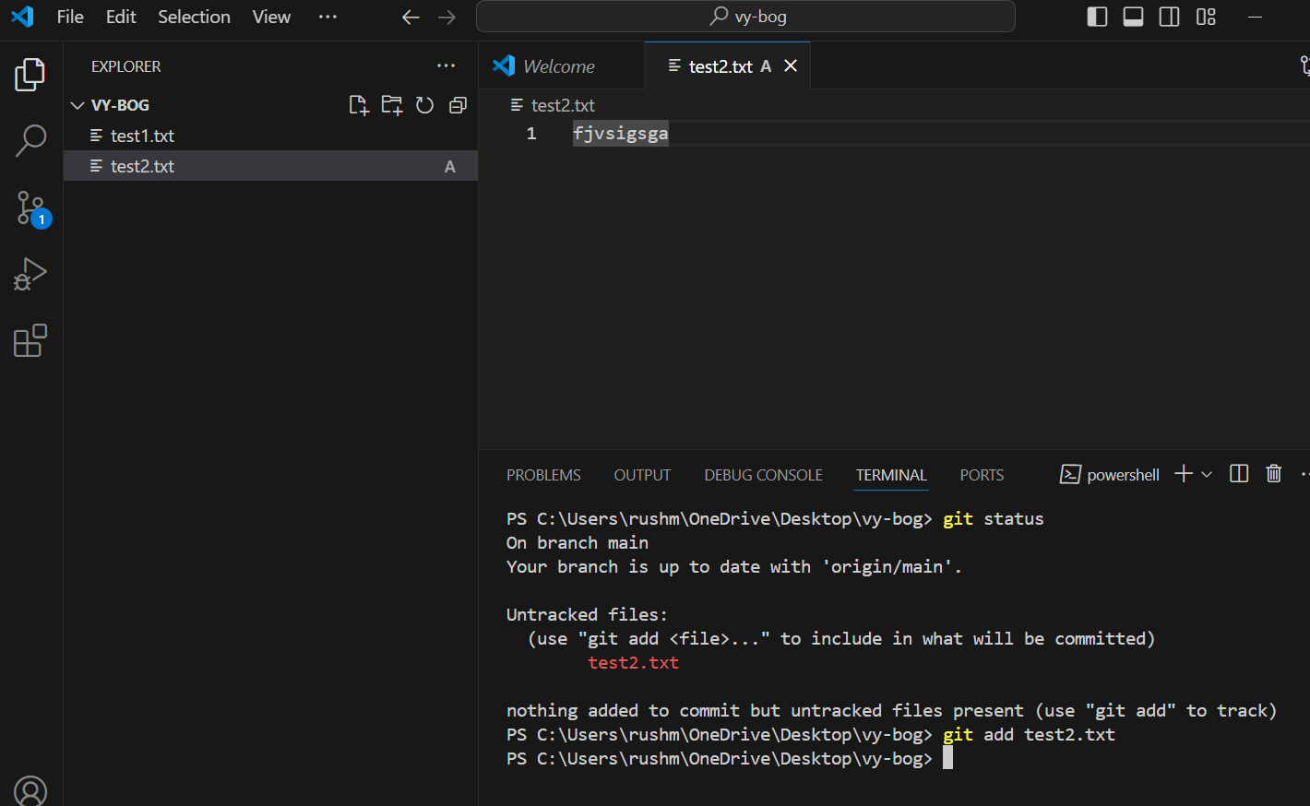

**U to a change added**

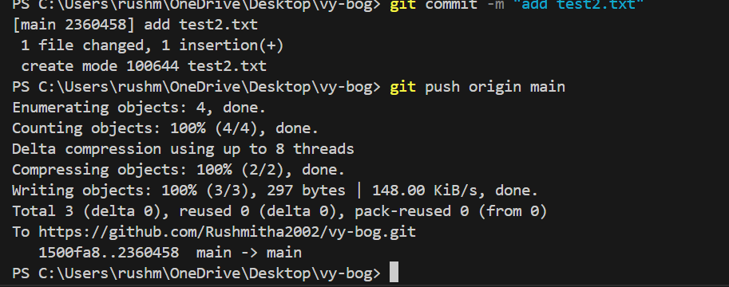

**"We need to push the main branch to 'origin'."**

**"If we download Git newly and start using it, it will ask for sign-in."**

**"If you need to make changes to the file again, you have to modify it."**

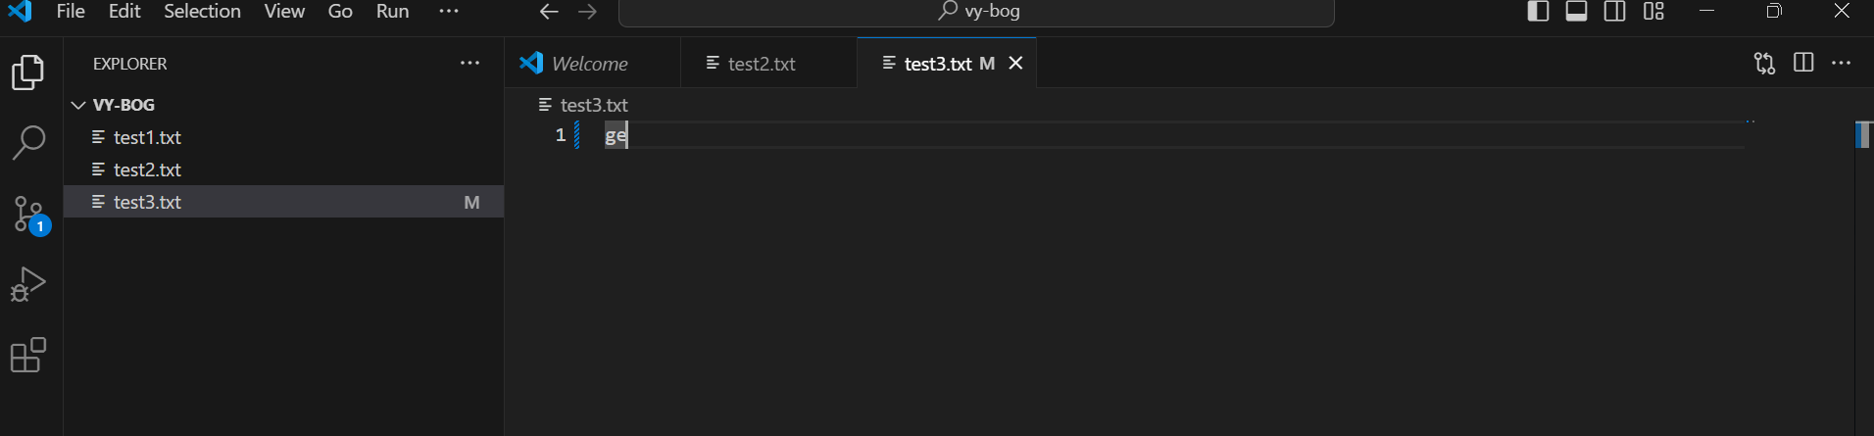

**"If you want to delete the file..."**

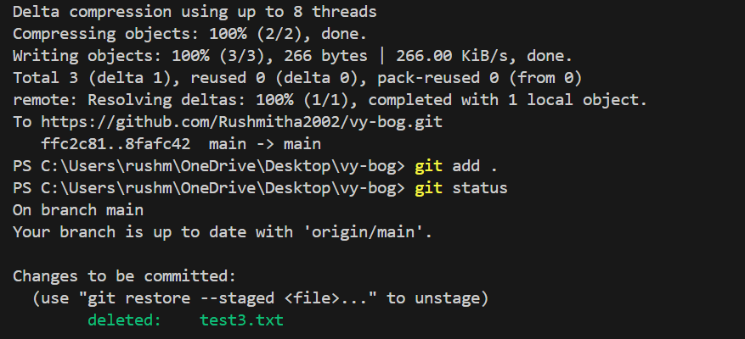

**"How to sync from GitHub to Visual Studio?"**

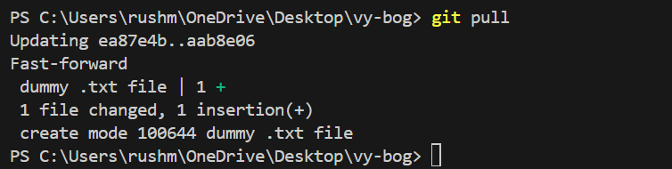

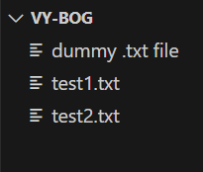

**INSERT-ADD-COMMIT-PUSH**

**ANYMODIFICATION-ADD-COMMIT-ADD-COMMIT-PUSH**

**BASIC FLOW TO GIT WORK**

**"Now, create a folder locally, add files to it, and push it to the repository."**

**"After creating the new folder, use 'cd ..' to go back and then 'cd new folder' to enter into the new folder."**

**"First, you need to navigate to the desired folder for Git, and then use the command 'git init' to initialize and create an empty repository."**

**Command git init**

**When you create a git init, two folders will be automatically created: one git folder and one working folder."**

**"In Git, regardless of adding 100 new files or modifying existing ones, when you use 'git add .', all of them will be staged as untracked."**

**Git add ./ smallopyg**

**Git remote add origin link copy**

**Git branch**





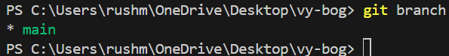

**"Let's create a new branch in GitHub and also in the local repository."**

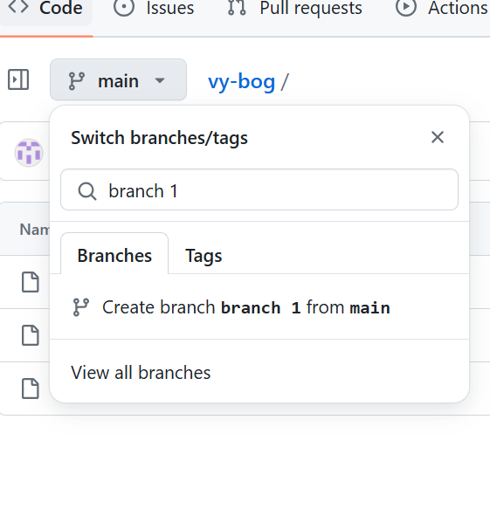

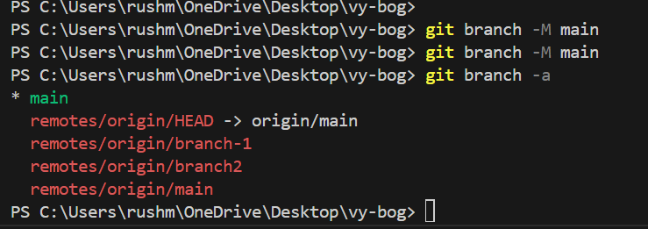

**"What branches are available if I type'git branch -a**

**"If I need to switch from the main branch to another branch..."**

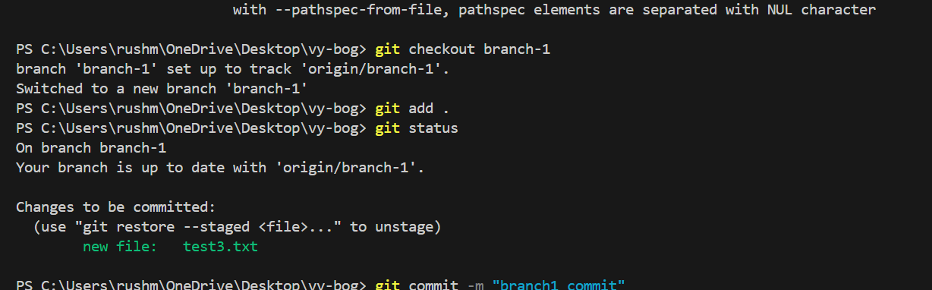

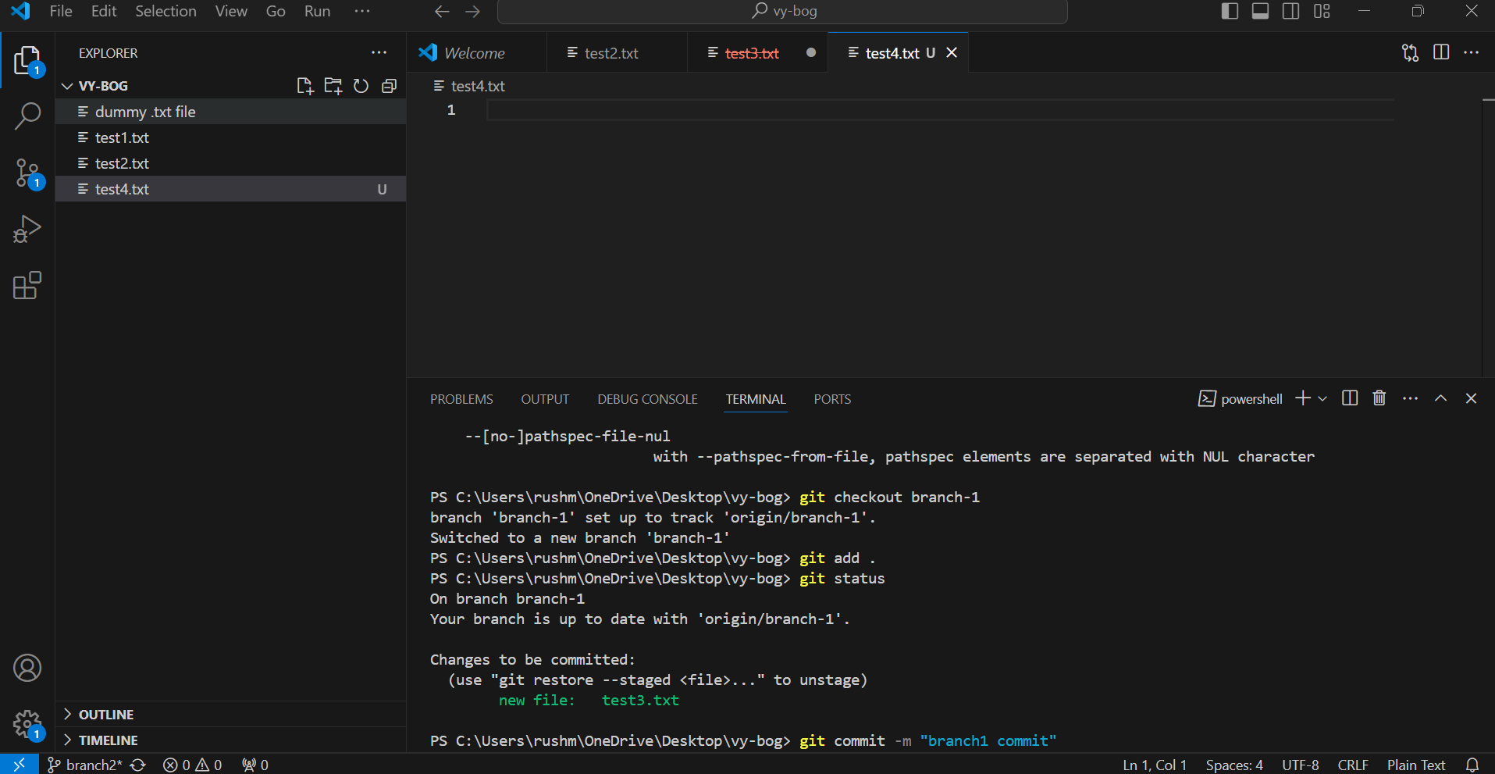

**"After creating another branch and adding files to it, how do we bring the code present in that branch into the text of that branch?"**

**Merging concept:**

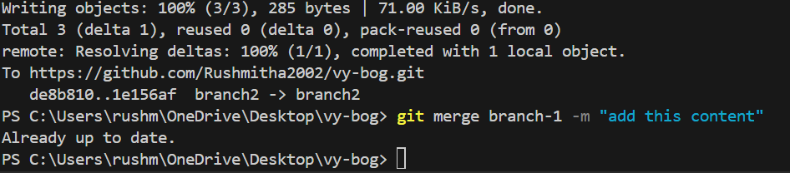

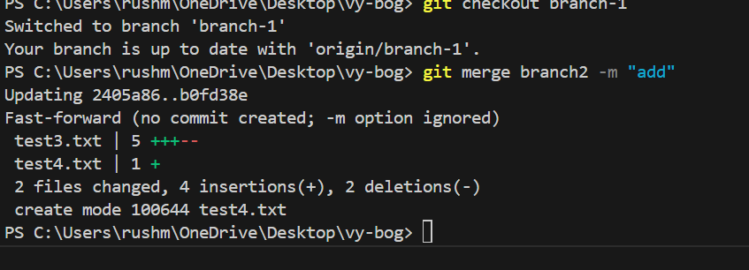

**Conflict concept**

**.gitignore**

**"The .gitignore prevents files or folders, specifically local Visual Studio files, from being pushed to GitHub."**

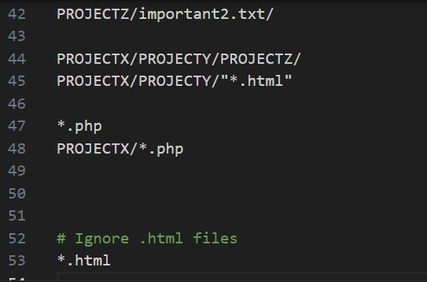

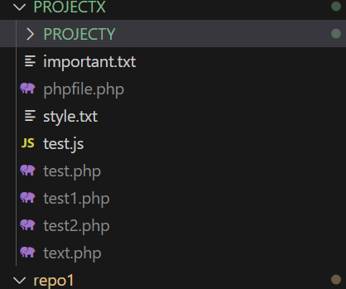

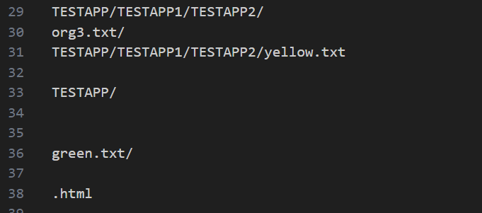

**"We can ignore multiple folders within folders, or a single folder, or some kinds of files."**

**Revert:**

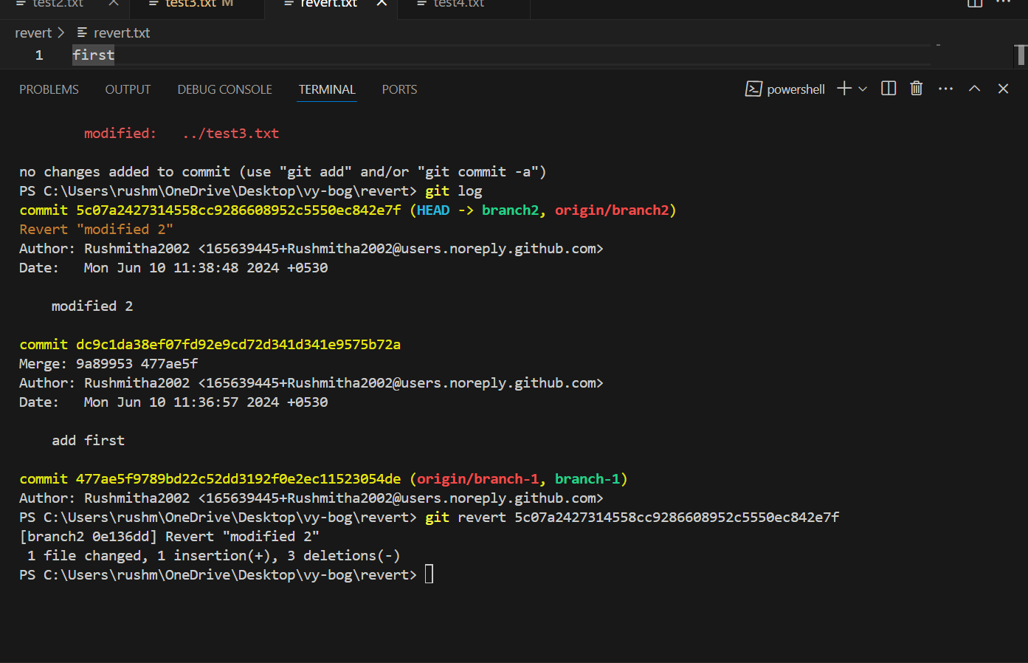

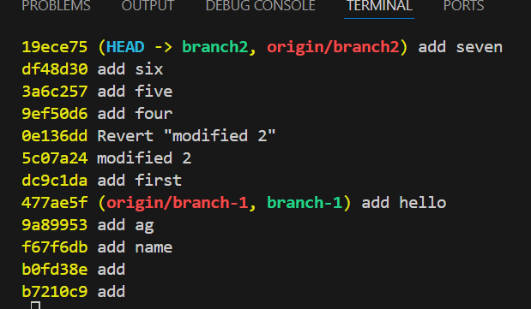

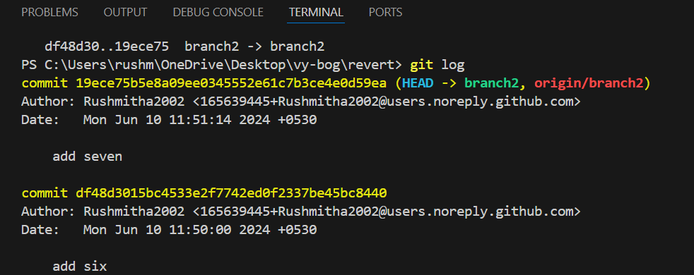

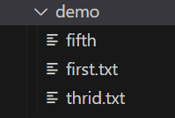



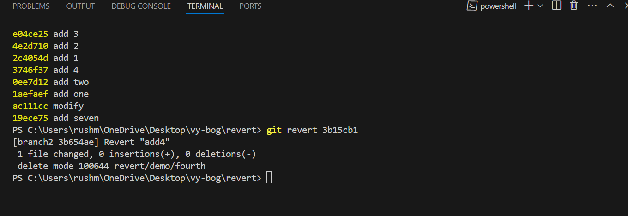

**"If we need to revert a file we don't want, we need to provide the commit ID to revert."**

**LOCAL**

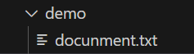

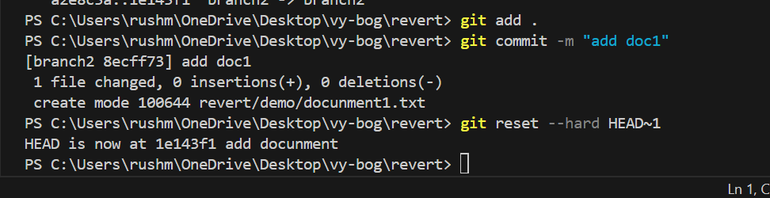

**"We need to revert the file immediately after committing it."**



